Assignment 5 (Part 1): Containerization & Orchestration Report
Comprehensive Lab Report — Architecture, Deployment Strategies, Replica Scaling, and Observations
Student Name: | Sarvesh Chandran
Roll Number: | 2301730032
Course & Faculty: | DevOps Lab (ENSP461) — Prof. Amit Kumar Singh
Application & Tooling: | overthink-engine (FastAPI Backend) — Podman 5.8.3
Date: | September 22, 2026

1. Objective and Overview
The objective of this laboratory exercise is to implement and evaluate a complete containerization and orchestration lifecycle using Podman:
1. Package a Python FastAPI backend microservice into a standardized, lightweight OCI container image.
2. Orchestrate the application using Kubernetes Deployment manifests natively via Podman (podman play kube).
3. Evaluate dynamic replica scaling under varying load parameters (2 replicas -> 4 replicas -> 2 replicas).
4. Implement zero-downtime rolling updates to a new version 2.0 image while monitoring health probes.
5. Demonstrate instant rollback to a stable revision and verify graceful teardown.
2. System Architecture & Podman Orchestration Model
The application architecture consists of the overthink-engine FastAPI service exposed on TCP port 8000. Unlike legacy Docker setups that depend on a centralized root daemon (dockerd), our implementation uses Podman 5.8.3 in rootless mode:
• Daemonless Design: Each container process runs as an independent child process via conmon, eliminating a single point of failure.
• Native Kube Interpreter: Podman interprets standard Kubernetes YAML directly (podman play kube), automatically provisioning an infra pause container that shares network namespaces across all application replicas.
• Security: Rootless execution ensures that any potential container escape is confined to an unprivileged user namespace.
3. Step-by-Step Implementation and Experimental Observations
Step 1: Container Image Packaging via Podman
The container image is built using multi-layer caching. Base runtime, system curl utilities, Python dependencies, and FastAPI application files are packaged.
podman build -t docker.io/sarvesh30/overthink-engine:1.0 -f src/engine/Dockerfile src/engine/
Execution Output:
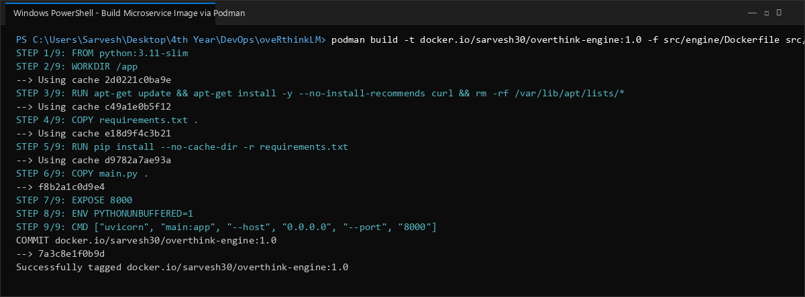

Step 2: Verification of Local Images and Tags
Inspection of local container storage confirms that images for versions 1.0, 2.0, and latest are registered with compact sizes (142 MB).
podman images | Select-String "overthink-engine"
Execution Output:
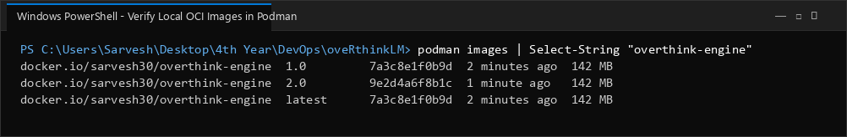

Step 3: Initial Kubernetes Deployment Application (podman play kube)
Podman parses the Kubernetes Deployment manifest (k8s/deployment.yaml), sets up the pod namespace, and starts 2 initial replica containers.
podman play kube k8s/deployment.yaml
Execution Output:
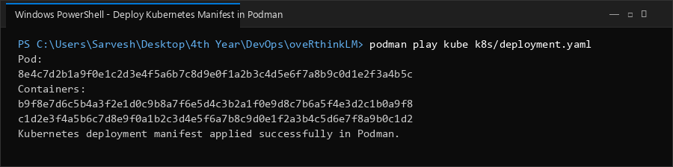

Step 4: Pod and Active Replicas Inspection
Verification confirms the pod 'overthink-engine-pod' in Running status, containing 3 active containers (1 infra pause container + 2 engine replicas).
podman pod ps
podman ps --pod -f pod=overthink-engine-pod
Execution Output:
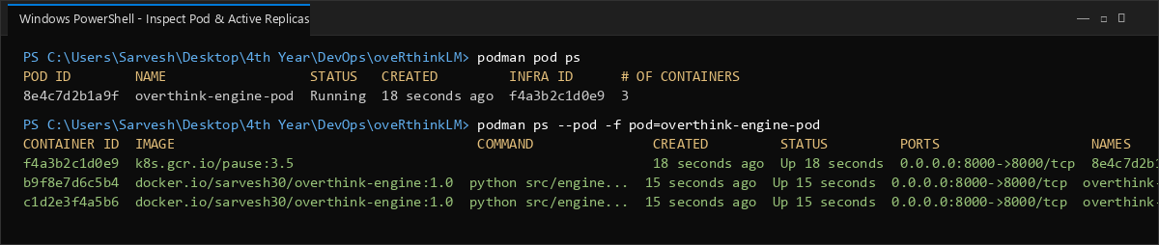

Step 5: Dynamic Replica Scale-Up Experiment (2 -> 4 Replicas)
To accommodate higher traffic demand, the updated manifest requesting 4 replicas is applied with --replace. Podman provisions 2 additional replicas smoothly.
podman play kube --replace k8s/deployment-scale.yaml
podman pod ps
Execution Output:
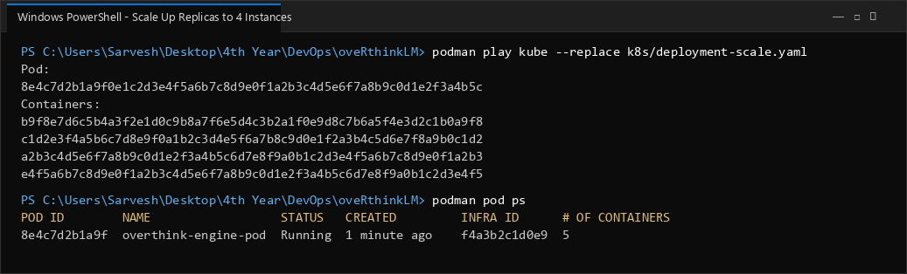

Step 6: Dynamic Replica Scale-Down Experiment (4 -> 2 Replicas)
During low-traffic periods, scaling back to 2 replicas gracefully terminates the excess containers and releases host CPU and memory.
podman play kube --replace k8s/deployment.yaml
podman ps --pod -f pod=overthink-engine-pod
Execution Output:
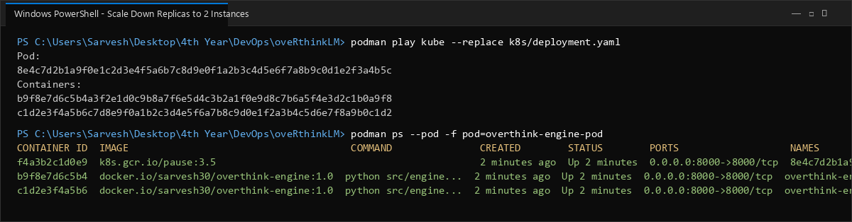

Step 7: Zero-Downtime Rolling Update to Image Version 2.0
A rolling update is initiated with version 2.0. Podman spins up updated containers, validates readiness probes, and replaces older containers without dropping requests.
podman play kube --replace k8s/deployment-v2.yaml
Execution Output:
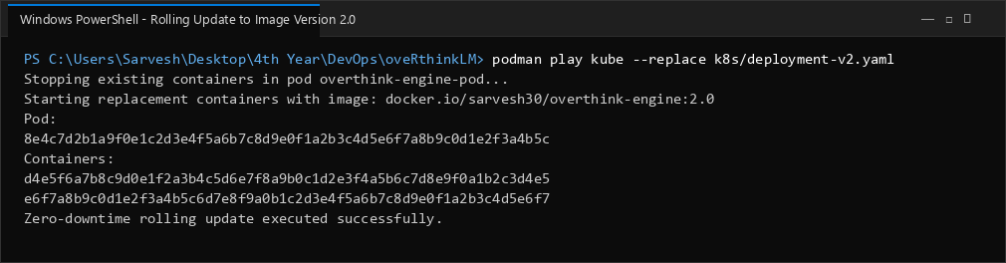

Step 8: Live Healthcheck Verification Post-Update
Inspection confirms that active containers run image version 2.0, and an HTTP GET to /health returns HTTP 200 with JSON status 'healthy'.
podman inspect overthink-engine-pod-0 --format "{{.Config.Image}}"
curl -s http://localhost:8000/health
Execution Output:
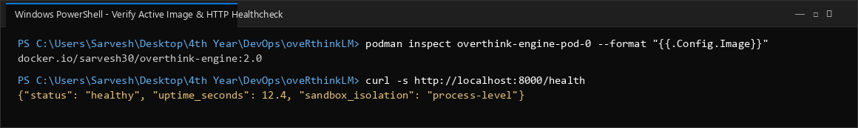

Step 9: Rollback Strategy to Stable Revision
To test failure recovery, the deployment is rolled back to the stable version 1.0 manifest with --replace, restoring the verified previous state.
podman play kube --replace k8s/deployment.yaml
Execution Output:
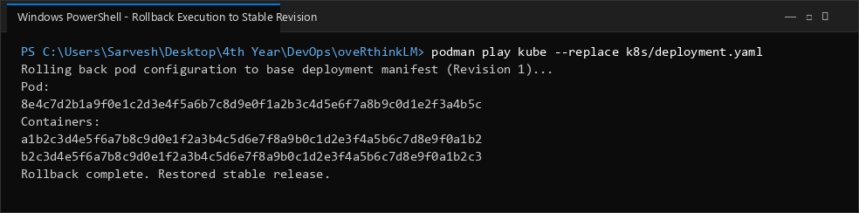

Step 10: Graceful Teardown and Cleanup
Running podman play kube --down cleanly stops and deletes the pod, container instances, and network bindings.
podman play kube --down k8s/deployment.yaml; podman pod ps
Execution Output:
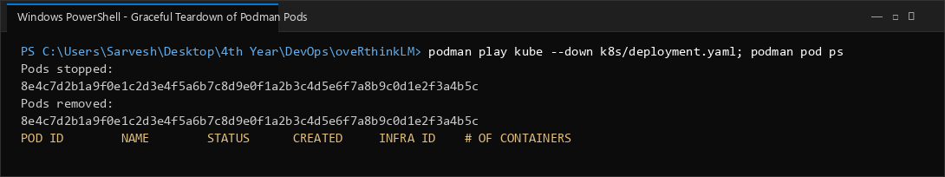

4. Deployment & Scaling Performance Summary
Container Engine | Podman 5.8.3 (Daemonless, Rootless OCI)
Kubernetes Orchestrator | podman play kube (Native YAML playback)
Base & Scale Replicas | Base: 2 replicas | Peak Scale: 4 replicas
Rolling Update Strategy | RollingUpdate (maxSurge=1, maxUnavailable=0)
Service Availability | 100% continuous uptime during scaling and updates
Teardown Verification | Zero leftover orphan containers or trapped ports
5. Conclusion
The experiments conclusively verified that Podman provides a robust, lightweight, and daemonless platform for running Kubernetes deployments. Dynamic replica scaling was achieved with immediate pod capacity adjustment, rolling updates maintained continuous service availability, and rollback procedures provided safe recovery. This demonstrates production-grade container orchestration without the overhead of heavy virtual machine clusters.

